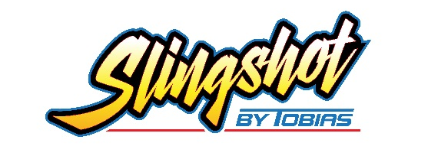

Speedway Entertainment 11 W Washington Ave Myerstown, Pa 17067

NAME:

ADDRESS:

CITY: STATE: ZIP:
2022 Order Form
E-MAIL:

PHONE: FAX:

CAR NUMBER: (1 NUMBER PER STATE, LETTERS ALLOWED)

DEPOSIT DATE:

AMOUNT:
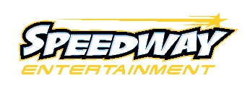
717-866-7450
FAX:717-866-7402
speede17@aol.com
www.speedwayentertainment.com

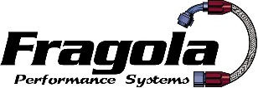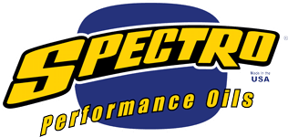

BODY COLOR: HOMETRACK:
CHASSIS COLOR: SEAT SIZE:
BUMPER COLOR: BELT COLOR:
WHEEL COVER COLOR: TIRE SIZE:
DRIVER HEIGHT: DRIVER WEIGHT:
GEAR: REFERRED BY:

Payment: 50% non-refundable deposit upon ordering Balance Due at time of pick up.
Previous driving experience is not necessary. Ability to handle race car can be at the race track’s discretion.
When purchasing the Tobias Slingshot™ I understand I must pay a yearly inspection and registration fees after purchased season of use. (Combined approximately $120.00—this may increase yearly) I also understand I will also be required to sign an agreement of sale at time of delivery.

X
Signature Required

All prices subject to change
___________________________________________________________________________________
SS1 Complete Car Assembled *Mandatory for first time buyer* $9,417.63
SS2 Non-assembled Kit Car $8,613.47
OPTIONS:
ST31-3 Full Containment Seat $646.27
ST31-31 Containment Seat Cover. $188.60
ST 60601 Aluminum Crank Support Option $99.09
ST 8300 Remote Fuel Pressure Gauge Option $69.25
ST72-1 Aluminum Bead Protector Ring $45.42 Each
ST557-1 Shock Coil Over Kits (4) Option $48.23 Each
ST6921-4 1 1/2” Alum. Carb. Spacer Option $52.24
ST 272-0 Splined Quick Release Steering Column $78.59
ST30-0 Splined Quick Release Steering Hub $48.28
ST 6033 Oil Pressure Light $26.99
ST41–0 Polished Interior Sheet Metal Option (add) $76.31
ST41 Multi Colored Body (add) $56.83
ST9992 Quick Jack $173.20
K&N 8012 Air Filter Outer Filter $21.98
ST 240-00 Candy Apple Powder Coating (add) $345.13
Over Bored Engine up to .040 over Call

RECOMMENDED SPARE PARTS
2 - Radius Rod $16.22 Each
2 - 60, 80, 100, 120 LB. Coil Springs $50.15 Each
1 - Bilstein Shock $95.00 Each
1– ST21-2 Double Rail Front Bumper $51.29
1 - Set Dirt Tires & Wheels
3 Wheels $40.40 per 1 RR Wheel $75.52 per
3 Tires $58.81 per 1 RR Tire $74.85 per

1 - K&N RU-0830 Air Filter $41.99
1 - # 40 Chain W/Clip (10 Feet + Clip) $66.14

* Please Circle All Options
