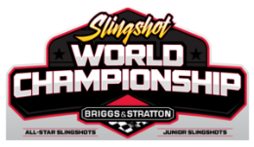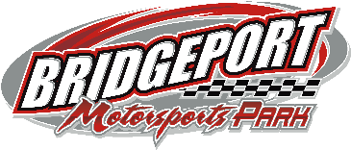

World Championship Weekend I Entry Form 2022
March 18-19-20, 2022 at Bridgeport Motorsports Park

$50 Early Entry (Paid by Mar 11) $25 Per Day at the Event

Pit Pass: Friday $30 Saturday $40 (All Day) Sunday $30
(No Pre-Paid Pit Passes)

All Star Slingshot____ Junior Slingshot____

DRIVERS NAME__________________________________________CAR#________AGE______

STREET ADDRESS________________________________________CITY_____________________________

STATE______________________ZIP______________________HOME PHONE (_______)_______________

CAR OWNER__________________________________SS# OR FED ID #___________________________

STREET ADDRESS________________________________________CITY_____________________________

STATE______________________ZIP______________________ HOME PHONE (_______)_______________

(No information is held on file, please fill out the full form)

TRANSPONDER #________________________________________________________________________________

SPONSORS_______________________________________________________________________________________

NO PERSONAL CHECKS ACCEPTED AFTER March 13, 2022
MAKE CHECK PAYABLE TO SPEEDWAY ENTERTAINMENT-
SEND TO 11 WEST WASHINGTON AVE MYERSTOWN, PA 17067

INFORMATION SHEET

Bridgeport Motorsports Park
83 Flood Gate Rd,
Swedesboro, NJ 08085

(856) 467-4407

bridgeportmotorsportspark.com

Camping permitted on Bridgeport Motorsports Park grounds (No Hookups)

*ALL CARS SUBJECT TO NEW JERSEY SAFETY INSPECTION*

Schedule
Four Races- Three Days

Friday: ¼ Mile
Practice- Time Trials- Heat Races- B Mains- A Mains (20/25 Laps) Practice at 6:30

Saturday AM: ¼ Mile
Practice- Time Trials- Heat Races- B Mains- A Mains (15/20 Laps) Practice at 1

Saturday PM: ¼ Mile
Practice- Heat Races- B Mains- A Mains (15/20 Laps) Practice at 6:30

Sunday: All Star Slingshots – Roval (20 Laps) / Junior Slingshots – ¼ Mile (20 Laps)
Practice- Time Trials- Heat Races- B Mains- A Mains Practice at 1

Payoff All Star Junior
Friday: $300 to Win- $30 to take the Green $125 to Win $20 to take the Green
Saturday AM: $200 to Win- $20 to take the Green $75 to Win $10 to take the Green
Saturday PM: $200 to Win- $20 to take the Green $75 to Win $10 to take the Green
Sunday: $300 to Win- $30 to take the Green $125 to Win $20 to take the Green

All cars must be exclusively supplied by Speedway Entertainment. 2022 Registration is mandatory.

2022 Rules will be enforced as they appear in the rule book

2022 World Championship Weekend Points System
1. 35
2. 33
3. 31
4. 29
5. 27
6. 25
7. 24
8. 23
9. 22
10. 21
11. 20
12. 19
13. 18
14. 17
15. 16
16. 15
17. 14
18. 13
19. 12
20. 11
21. 10
22. 9
23. 8
24. 7
25. 6
26. 5
27. 4
28. 3
29. 2
30. 1

